Coursework 1 Report
Greg Young
40282075@live.napier.ac.uk
Edinburgh Napier University – Web Technologies (SET08101)

Introduction
This coursework entails designing and producing a website that allows a user to encode text through the use of two different cyphers or encoding schemes. The website should include:
i) A way in which the user is able to type their text message to be encoded,
ii) A way in which the resulting encoded message can be communicated back to the user,
iii) The option to select between cyphers which will encode the given text message,
iv) A way in which the user can initiate the process of the chosen cypher to encode the text,
v) The ability to decipher the encoded text to return the original plaintext.
The cyphers I have chosen for this coursework are, firstly, a special type of Caesar cipher called ROT13. This particular cypher involves the shifting of the basic Latin alphabet by 13 places. In other words, the plaintext letter given by the user will be replaced with the letter 13 places ahead of it in our standard alphabet. Should the plaintext letter be found in the second half of the alphabet then the rule still applies as we can imagine that the end of the alphabet is followed directly by the beginning (a=1st, 26th+1 etc).
Secondly, I have chosen a type of simple substitution cypher where the plaintext letter corresponds uniquely to a different letter of the alphabet. An alternative alphabet with the same properties as our standard alphabet exists with the only difference being the order of letters. Each letter is always replaced with the same letter in the alternate alphabet.

Software Design
Through the use of an HTML document, the approach I will take to create this webpage is to allow the user to type their text message into an input text box on screen and provide two cipher buttons which gives the user the ability to choose which method will encode their message. Both buttons will run the corresponding cipher between two different javascript files (Caesar cipher and simple cipher). The encoded message will appear in an area of the screen below the input box. There will also be another two buttons on screen, both of which will decipher the message through two more javascript files corresponding to which method was used to encode the text originally. The decoded text will appear underneath the encoded text. A CSS file will also be created to implement the style features of the HTML document that the user will see on screen.
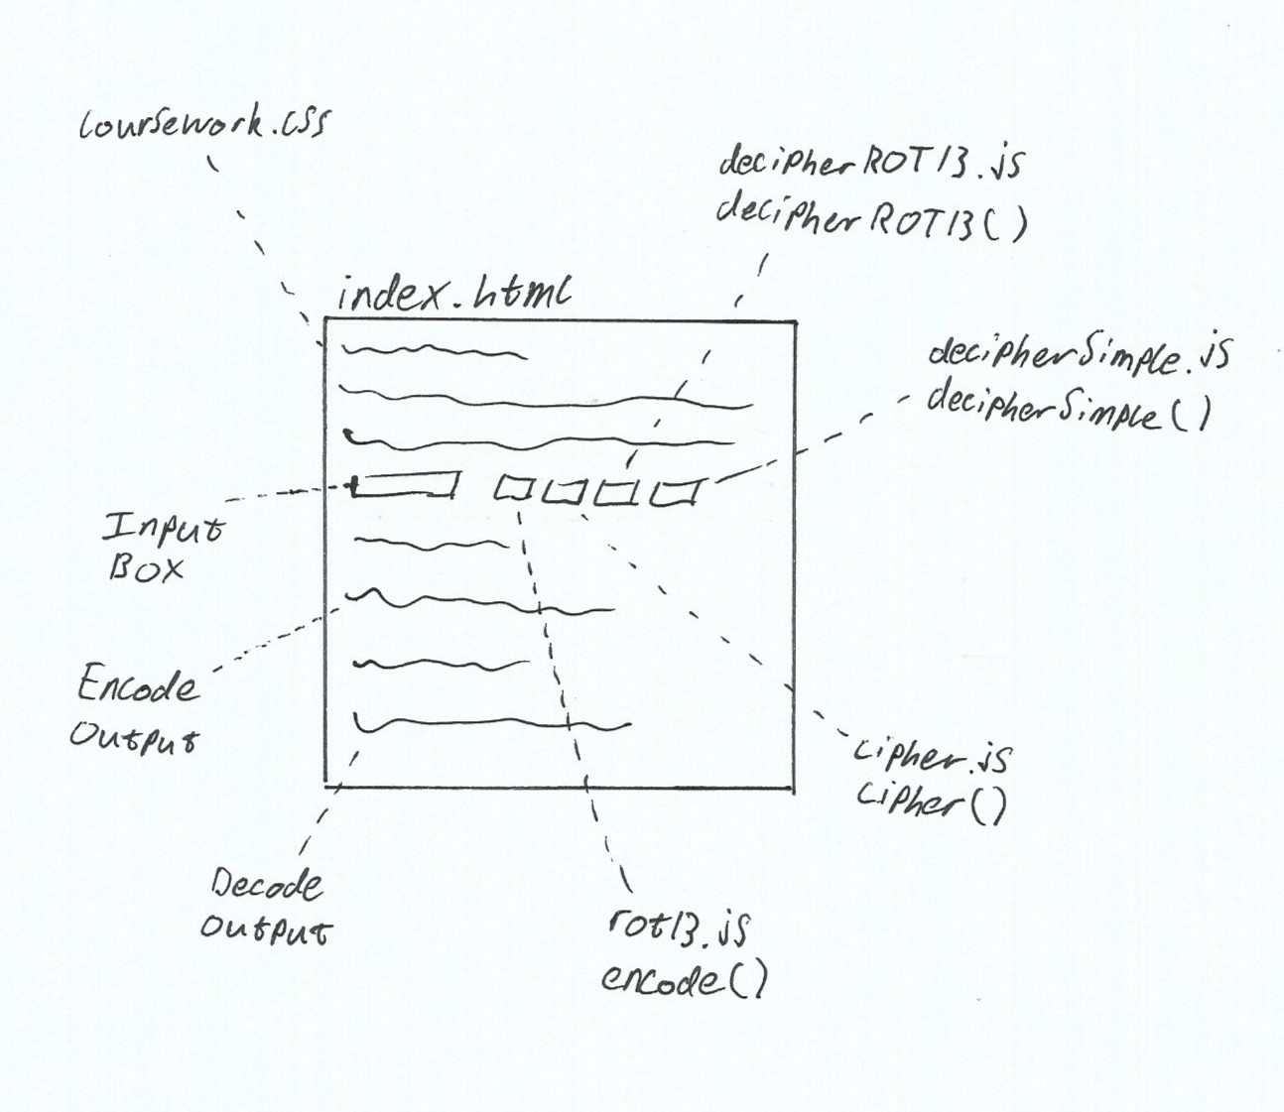Figure 1: html design
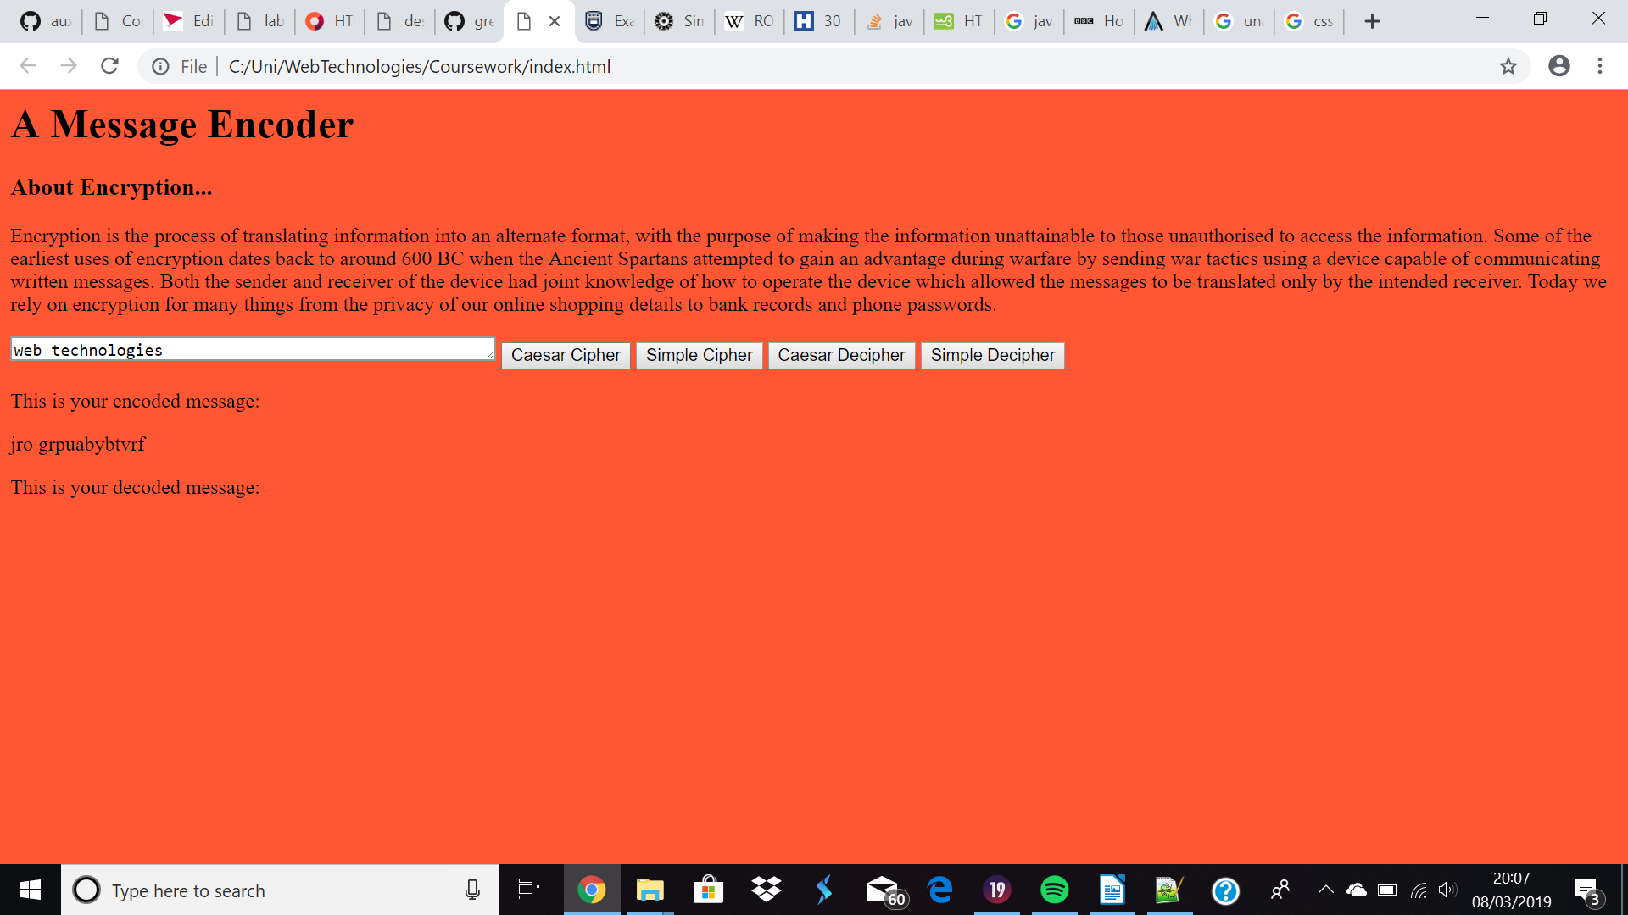Figure 2: index.html

Implementation
Figure 2 below shows the html file run in google chrome. It contains a title, a brief background on the topic, an area to submit a text message via an input box, 4 buttons which each run separate JavaScript files (2 encoders and 2 decoders) and an area which displays the output of the encoded and decoded message.
Figure 3 and 4 below show the JavaScript code of both ciphers – the Rot13 Caesar Cipher and the Simple Substitution Cipher respectively.
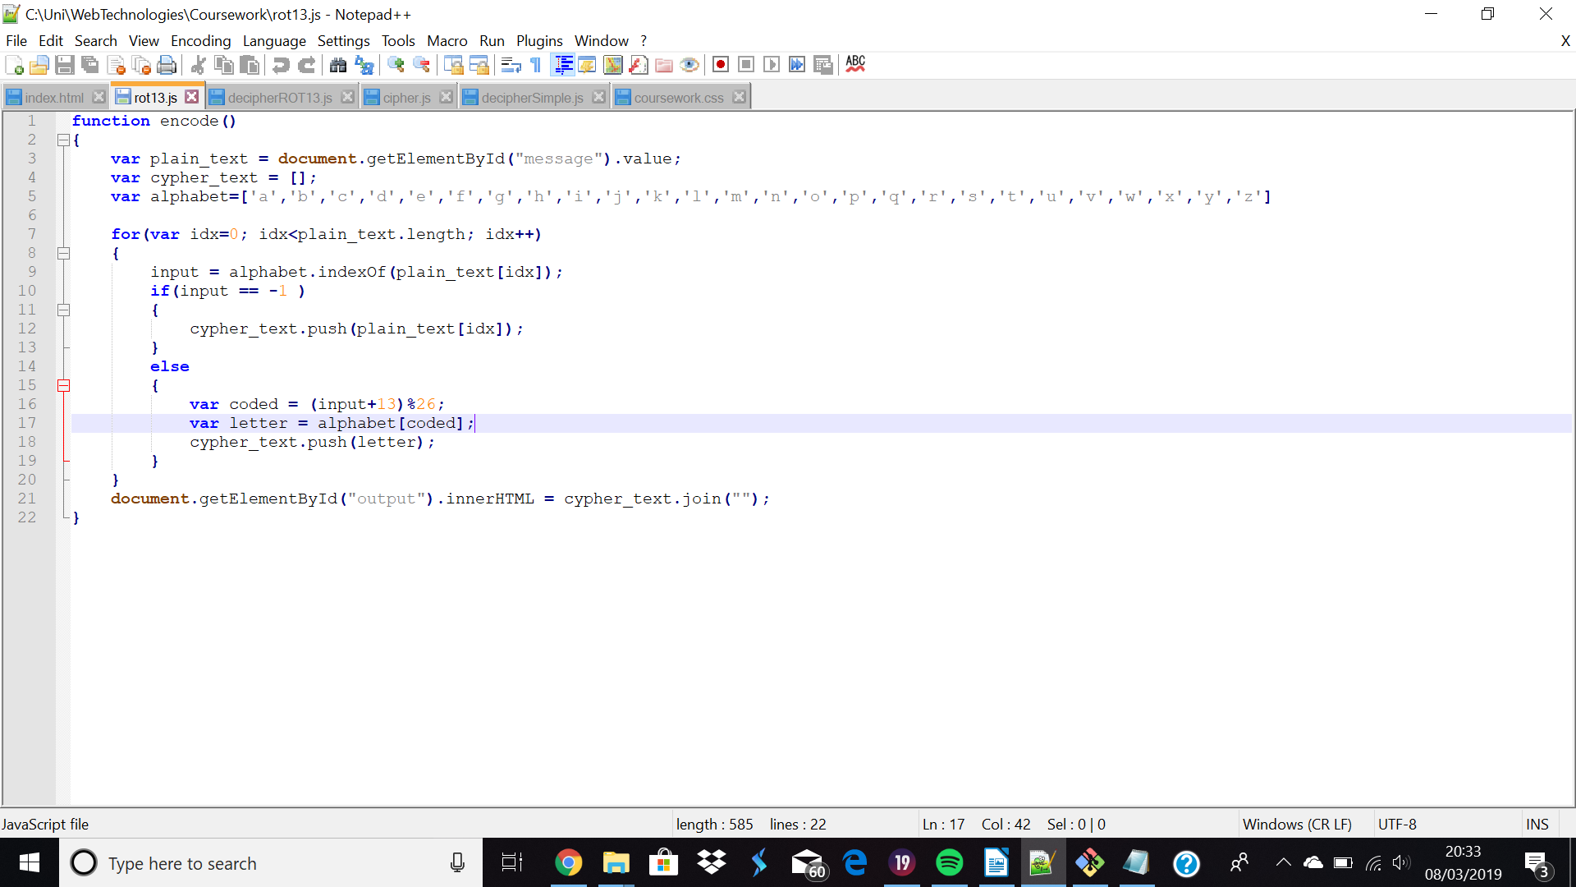Figure 3: Rot13 Caesar Cipher
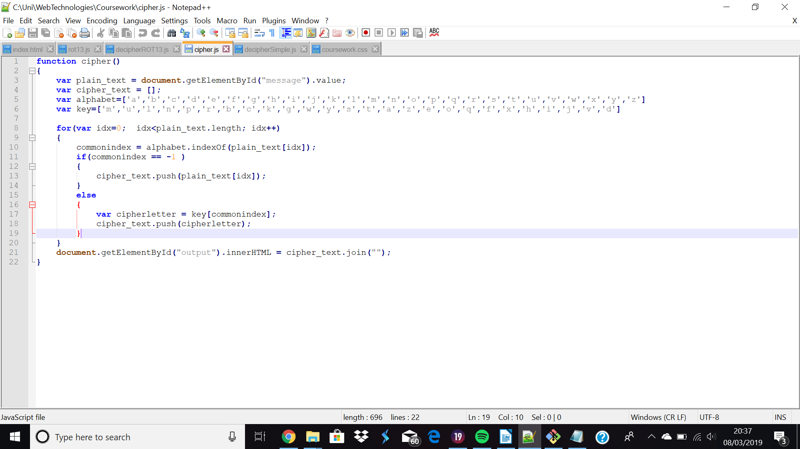Figure 4: Simple Substitution Cipher
Figure 5 shows the CSS code for the design of the HTML document.
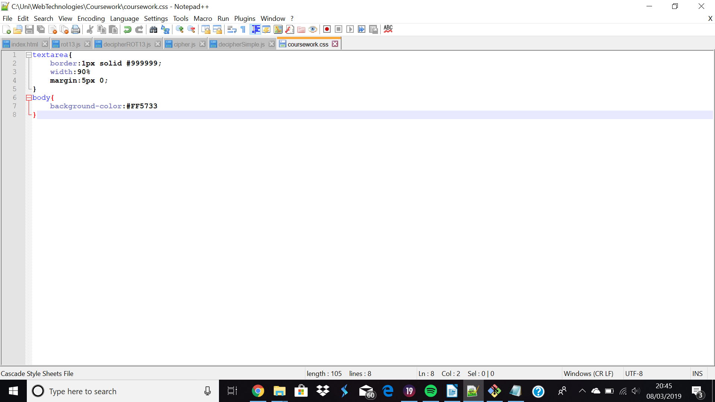Figure 5: coursework.css

In the CSS code, “textarea” refers to the input box which the user types their text message into. “Body” refers to the main contents of the html page, in this case, the background colour.

Critical Evaluation
In terms of the criteria set out in the introduction to this report, the website contains 4 of the 5 essential components. It allows the user to type a written message, it returns the encoded text, it allows the user to choose between ciphers and it allows the user to initiate the encoding of their message. The inclusion of a decipher to decode the encrypted text to plaintext is the one missing component which was not implemented successfully. Other than this, the website serves its purpose and nothing more. The implementation of both ciphers and the users interaction with the ciphers is straightforward with the use of buttons and the output in the form of text.

Personal Evaluation
This assignment has without doubt aided me with knowledge of both HTML and JavaScript, being relatively unfamiliar and having limited experience with both. This being said, it was ultimately a lack of knowledge of JavaScript which prevented me from successfully implementing the decoders to return the plaintext message. Reflecting on how I tackled this coursework I feel like I could have been capable of being more creative and going beyond the bare minimum requirements of the coursework had I not focussed so much time attempting and failing to implement the mechanism to decipher the encoded text to recover plaintext.

